Hive Lab:

Stopping dfs and yarn processes

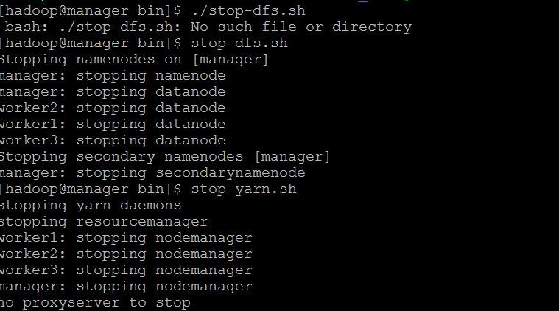

Restarting hadoop dfs and yarn.

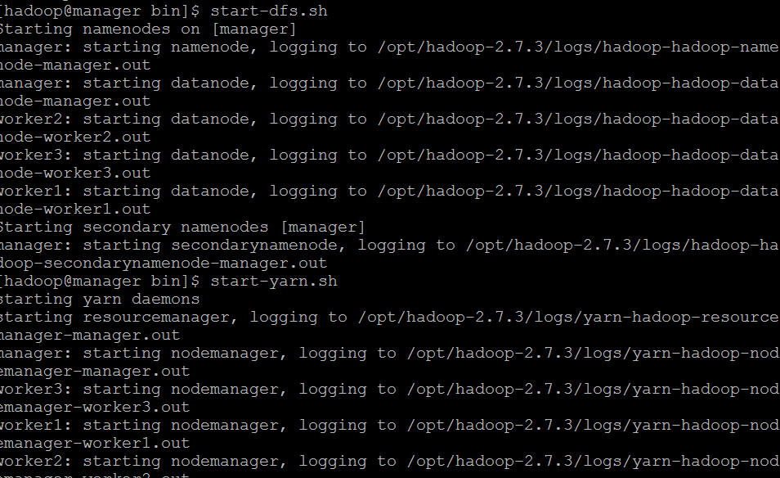

Running schemaTool to create metastore_db folder

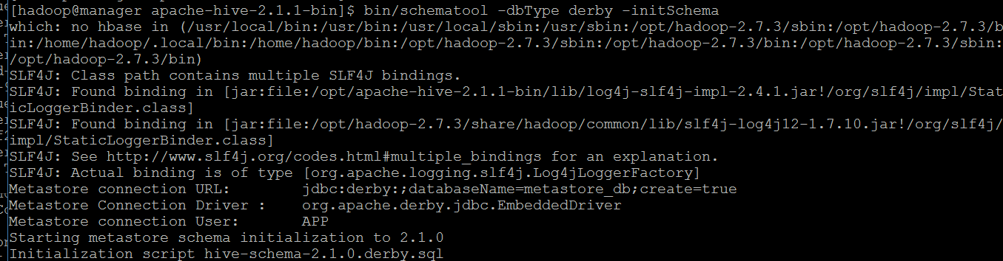

Starting beeline on localhost:10000

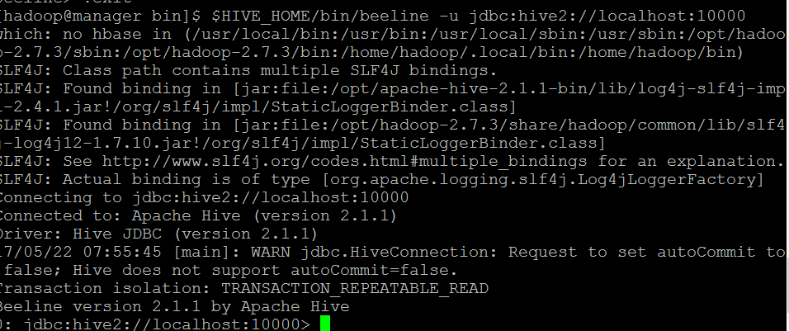

Movie Lens Exercise on Standalone Hive with embedded Derby:

Retrieved rows from u-data table

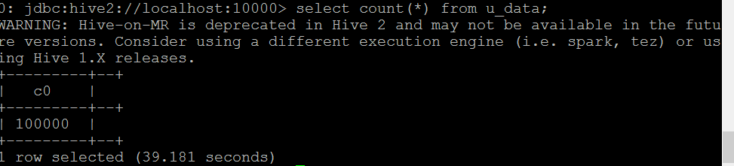



Applying python sort function to unixtime column and retrieving groups of movies per weekday

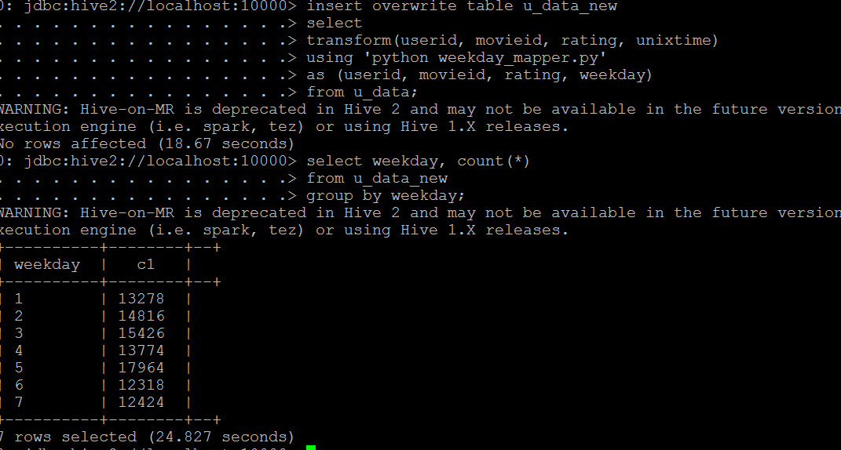

MovieLens exercise on Derby Network server mode:

Starting Hive Beeline and showing tables.

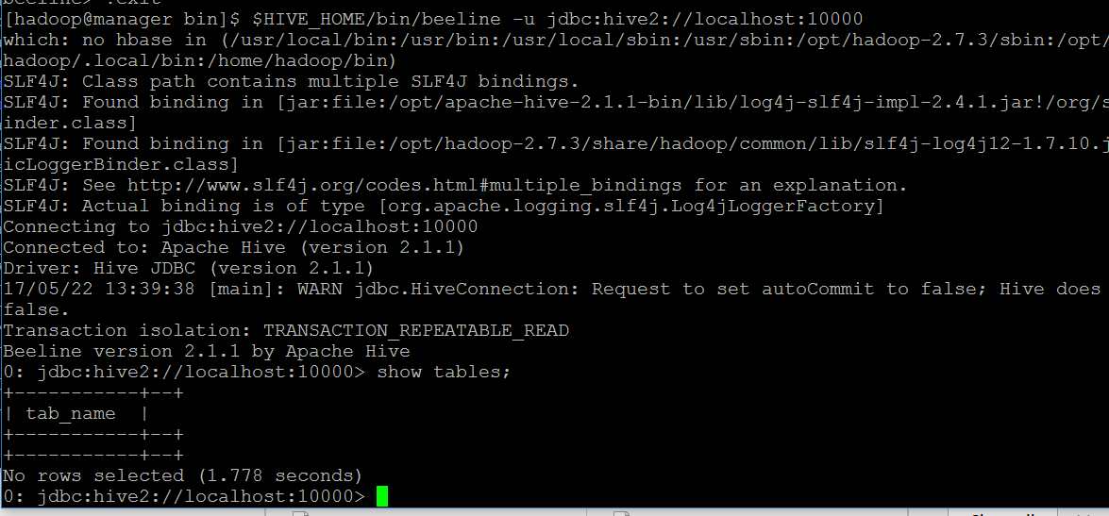

Created table u_data loaded data into table u_data

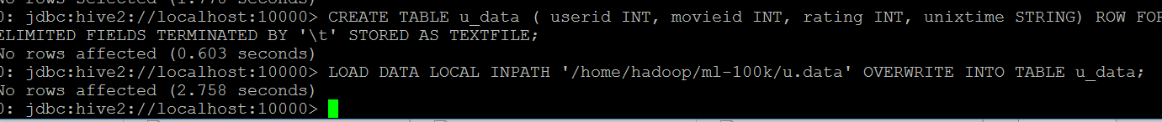

Loaded data successfully into u_data table

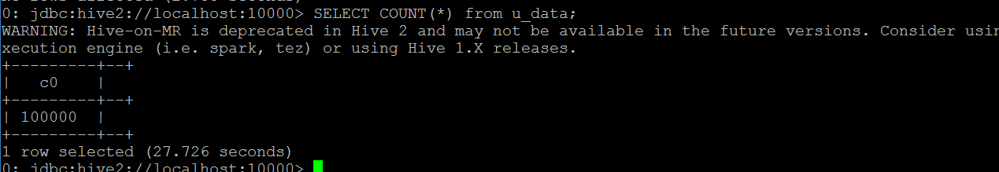

Created new u_data_new table



Added weekday_mapper,py function



Applied python function to convert unix time column to weekday

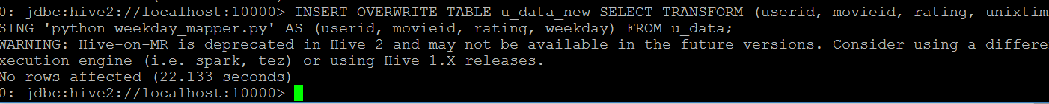

Queried records based on weekdays

